STALKER: A System for Tracking Affected Learning Knowledge, Erasure and Reporting

Subtitle: A Prototype for Record-Level Training Lineage and Model-Impact Analysis

Abstract:
Machine-learning systems are trained using datasets that may contain user-related or personal information. When a particular record later requires investigation or deletion, an organization may not know which dataset versions, training runs, or trained models used that record. This project proposes STALKER, a prototype for recording the relationship between individual training records, dataset versions, training runs, and model versions. The initial system will assign internal identifiers to records, preserve dataset versions, capture actual training-record identifiers during model training, and provide a search function for identifying connected models. The project will use a controlled public dataset and a simple machine-learning classifier. The first phase will evaluate lineage accuracy, record completeness, dataset-version correctness, model-link correctness, and search behavior. Deletion requests, retraining, and technical reporting are planned extensions. STALKER is intended as a technical traceability prototype and does not claim legal compliance or guaranteed removal of learned information.
Keywords: Machine learning, data lineage, data provenance, model tracking, dataset versioning, machine unlearning, data deletion, AI governance.

I. Introduction
Machine-learning models learn patterns from training data. During model development, data may pass through several stages, including collection, cleaning, preprocessing, splitting, training, evaluation, and deployment. If the organization does not preserve the history of these stages, it may become difficult to determine which data contributed to a particular model.
This issue becomes important when a person requests deletion or correction of their personal data. Article 17 of the General Data Protection Regulation provides a right to erasure in specified circumstances. However, removing a record from the original database does not automatically identify all trained models that may have used it.
The European Data Protection Board’s technical report explains that implementing data-subject rights in AI systems involves both deleting the personal data used for training and addressing the influence of the relevant data points in the trained model. It identifies data curation and provenance as prerequisites and discusses retraining as one possible method, particularly for smaller models.
The challenge can be represented as follows:
Training record
↓
Dataset version
↓
Training run
↓
Model version
If these relationships are not recorded, an organization may not be able to answer a basic question:
- Which model versions used this particular record?
STALKER proposes a focused prototype for answering this question. The first version will not attempt to solve every machine-unlearning problem. Instead, it will establish a reliable record-level lineage foundation that can later support deletion requests, retraining, model comparison, and technical reporting.

II. Background and Motivation

A. Data provenance and lineage
Data provenance describes the origin, history, and transformations associated with data. Data lineage focuses on how data moves through a workflow and how one data artifact is connected to another.
For STALKER, provenance and lineage include:
- Dataset source.
- Dataset version.
- Record identifier.
- Preprocessing operations.
- Training-run identifier.
- Model version.
- Model evaluation metrics.
- Time of training.
- Software or parameter information.
NIST guidance emphasizes documenting training-data sources and provenance and describes the importance of managing information about data origins, transformations, dependencies, and metadata.airc.nist+1

B. Machine-learning model tracking
Model tracking systems record experiments, parameters, evaluation metrics, model files, and versions. These systems help reproduce experiments and understand how a model was produced.
However, a general model registry usually focuses on the model and training run rather than providing a simple search from an individual training record to every affected model. STALKER will study this record-level search workflow.

C. Machine unlearning and retraining
Machine unlearning is a research area focused on removing or reducing the influence of selected training data from an already trained model. Existing techniques differ in their computational cost, accuracy, privacy guarantees, and verification methods.
Full retraining is conceptually simple: remove the selected record from the training dataset and train a new model using the remaining data. However, repeated full retraining may be expensive for large models or large datasets. Approximate unlearning methods may be faster but are more difficult to verify.edpb.europa
For this reason, STALKER will first focus on identifying affected models accurately. Retraining and unlearning will be considered only after the lineage foundation has been validated.

III. Literature Study

A. Data provenance and transparency
Recent work has shown that AI training data may be widely sourced, incompletely documented, and difficult to audit. The Data Provenance Initiative provides infrastructure for examining dataset sources, licenses, creators, languages, geographies, and derivation chains.arxiv+1
Research on AI data authenticity, consent, and provenance also identifies weaknesses in current practices for collecting and documenting training data. These findings support the need for systems that record where data came from and how it was used.proceedings.mlr
NIST guidance similarly recommends documenting data sources, origins, transformations, augmentations, labels, dependencies, constraints, and other metadata.airc.nist

B. Model lifecycle provenance
Existing ML lifecycle tools provide different forms of dataset, experiment, model, and pipeline tracking. MLflow supports dataset tracking, experiment tracking, and model registry functionality. Its model registry links a model version to the run that produced it.mlflow
OpenLineage provides an open standard for collecting metadata about datasets, jobs, and runs. Its object model is designed to represent how datasets move through complex workflows.openlineage
Cloud platforms such as Amazon SageMaker and Google Vertex AI also provide model and artifact lineage. SageMaker can track workflow steps from data preparation to model deployment, while Vertex AI Metadata records relationships between artifacts and the information that contributed to their creation.docs.aws.amazon+1
These systems demonstrate that model and data traceability are established needs. However, they are generally broad platforms or infrastructure standards. STALKER narrows the problem to a simple record-to-model search workflow suitable for an academic prototype.

C. Machine unlearning
Machine-unlearning research studies how a model can remove or reduce the influence of selected training data. Recent surveys discuss exact unlearning, approximate unlearning, verification, privacy attacks, and computational trade-offs.
The literature shows that unlearning is difficult because:
- The exact influence of each record may be unknown.
- Training is often stochastic.
- The model may have been trained incrementally.
- Different methods provide different guarantees.
- Similarity to a retrained model does not automatically prove deletion.
- Deletion can affect accuracy, fairness, and retained-data performance.
The EDPB technical report explains that data provenance is necessary but not sufficient because provenance does not itself describe how data influenced model parameters. It also states that retraining can be effective for smaller models but may be expensive for larger systems.edpb.europa

D. Literature-based project decision
The literature supports the following project decision:
STALKER should begin with accurate record-level lineage and model-impact search. It should not begin by claiming a new machine-unlearning algorithm or complete data deletion.

IV. Preliminary Research Gap
Existing research and software tools provide capabilities for dataset versioning, experiment tracking, model management, data provenance, pipeline lineage, retraining, and machine unlearning. However, these capabilities are often distributed across different systems or require significant infrastructure and integration.
The preliminary gap addressed by STALKER is:
The lack of a simple, beginner-friendly prototype that connects an individual training record to its dataset version, training run, and model version through a searchable workflow and prepares the foundation for later deletion processing.
STALKER does not claim that record-level lineage, model tracking, or machine unlearning is individually new. Its proposed contribution is the focused integration of these relationships for educational demonstration and controlled evaluation.
This gap is preliminary and must be refined after a broader literature review, product comparison, and prior-art search.

V. Proposed Idea
STALKER will create an internal relationship between each record and the model-training workflow.

A. Record identifiers
Each dataset row will receive a stable internal identifier, such as:
REC-000001
REC-000002
REC-000003
These identifiers will be used for experimental tracking. They will not represent real personal identities.

B. Dataset versions
The original dataset will be stored as a specific version:
DATASET-V1
If a record is later removed, a new version will be created:
DATASET-V2
The original version will not be overwritten.

C. Training runs
Each training attempt will receive a unique identifier:
RUN-001
The system will store the dataset version, algorithm, parameters, random seed, timestamp, and evaluation metrics.

D. Model versions
Each trained model will receive a unique identifier:
MODEL-001
The model will be linked to the training run that produced it.

E. Automatic lineage capture
The training program—not a person manually entering information—will record the exact training-record IDs used during the training process.
The resulting relationship will be:
REC-000245
↓
DATASET-V1
↓
RUN-001
↓
MODEL-001

VI. Methodology

A. Dataset selection
The prototype will use one small, documented public tabular dataset. The dataset will be selected based on:
- Public availability.
- Clear source and usage information.
- Suitable classification target.
- Manageable size.
- Fast repeated training.
- No direct use of real sensitive identities.
- Suitability for future retraining experiments.
The UCI Bank Marketing dataset is a possible primary dataset because it provides a documented classification task and is licensed under CC BY 4.0.
The Iris dataset may be used for initial technical testing because it is small and simple. The Adult dataset may be retained as an optional backup or fairness-oriented extension.

B. Data preparation
The original dataset will be preserved. A processed version will be created with an internal record_id column.
The system will record:
- Dataset name.
- Source.
- Version.
- Record count.
- Feature columns.
- Target column.
- Missing-value handling.
- Preprocessing steps.
- File hash.

C. Model training
The initial prototype will use one simple supervised classification model, such as a Decision Tree Classifier or Logistic Regression.
The dataset will be separated into training and test subsets. The model will be trained only on the training subset. The test subset will be used to measure performance on unseen records.
The system will store:
- Training-run ID.
- Dataset-version ID.
- Algorithm.
- Hyperparameters.
- Random seed.
- Training-record IDs.
- Test-record IDs separately.
- Accuracy and other selected metrics.
- Model artifact path.
- Date and time.

D. Database storage
The initial SQLite database will contain the following tables:
- records
- dataset_versions
- dataset_records
- training_runs
- models
- training_lineage
The training_lineage table is central to the project. It will store:
run_id
record_id
This table represents which records were actually used during training.

E. Lineage search
An authorized user will enter a record identifier:
REC-000245
The system will search:
- Dataset versions containing the record.
- Training runs using those versions.
- Model versions produced by those runs.
The output will show:
Record ID: REC-000245
Dataset version: DATASET-V1
Training run: RUN-001
Model version: MODEL-001

F. Future deletion and retraining extension
After the MVP is validated, the system may support:
- Creating a deletion request.
- Finding affected model versions.
- Removing the record from the working dataset.
- Creating a new dataset version.
- Retraining the affected model.
- Comparing the original and updated models.
- Generating a technical evidence report.
These features are planned extensions and should not be described as implemented until they are tested.

VII. System Architecture
The proposed system will use a Python-based full-stack design.
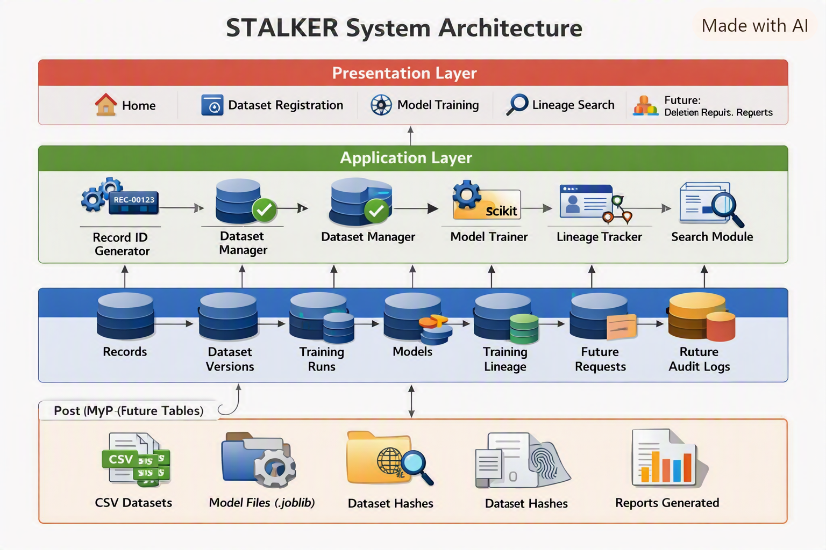

Technology stack:
Layer | Technology
Programming | Python
Interface | Streamlit
Data processing | pandas
Machine learning | scikit-learn
Database | SQLite
Model storage | joblib
Version control | Git and GitHub
Optional testing | pytest
Optional deployment | Streamlit Community Cloud

VIII. Evaluation Plan
The MVP will be evaluated using functional and lineage-based tests.

A. Record-ID accuracy
Verify that every record receives one unique identifier.

B. Dataset-version accuracy
Verify that changes create a new version and do not overwrite the original version.

C. Lineage completeness
Compare the record IDs actually passed to the training process with the IDs stored in the database.
The expected result is:
Missing training IDs = 0
Extra training IDs = 0

D. Model-link accuracy
Train two models using different dataset versions and confirm that each model is connected to the correct training run and dataset version.

E. Search accuracy
Search for:
- A record known to be used in training.
- A record not used by a particular model.
The system should return the correct model only for the appropriate record.

F. Reproducibility
Repeat the training process using the same dataset version, parameters, and random seed. The lineage should remain the same, and model metrics should be comparable.

G. Model performance
Measure accuracy, precision, recall, F1-score, or other suitable metrics. Results must be generated from the actual experiment and must not be fabricated.

IX. Expected MVP Outcome
The expected MVP outcome is a working local prototype that can:
- Import a public dataset.
- Generate internal record IDs.
- Register a dataset version.
- Train one simple model.
- Store training-run metadata.
- Capture actual training-record lineage.
- Search for a record ID.
- Display the connected model.
- Produce test evidence showing lineage correctness.

X. Limitations
- The prototype will use a small public or de-identified dataset.
- It will support selected conventional models only.
- It will not represent every possible AI architecture.
- It will not guarantee complete removal of learned information.
- It will not provide legal certification.
- It will not automatically prove GDPR compliance.
- It will not initially implement advanced machine unlearning.
- It will not use real personal identities.
- Its results will depend on the selected dataset, model, and evaluation method.
- Cloud deployment, if used, will be a demonstration environment rather than a production system.

XI. Ethical Use of AI Assistance
AI tools may assist with:
- Explaining technical concepts.
- Improving grammar.
- Suggesting code structure.
- Generating test-case ideas.
- Organizing documentation.
The team must:
- Verify every factual claim.
- Read and understand generated code.
- Test all generated code.
- Cite original sources.
- Avoid fabricated references.
- Avoid fabricated results.
- Rewrite content in the team’s own understanding.
- Disclose AI assistance if required by the institution or publication venue.
IEEE guidance emphasizes clear organization, original work, proper attribution, and accurate reporting. It also warns against fabrication, falsification, plagiarism, and exaggerated claims.

XIII. Conclusion
STALKER addresses a practical traceability problem in machine-learning workflows. When a data record is used to train a model, an organization may need to identify the dataset versions, training runs, and model versions associated with that record. Existing platforms provide broad capabilities for dataset tracking, model management, and data lineage, while machine-unlearning research studies the removal of selected data influence. STALKER proposes a focused academic prototype that connects these concepts through record-level lineage and searchable model-impact relationships. The MVP will validate the accuracy and reproducibility of this connection before implementing deletion requests, retraining, and technical reporting.

References
Use verified sources in your final IEEE reference list, including:
- EUR-Lex, “Regulation (EU) 2016/679,” Article 17.
- EDPB, “Effective implementation of data subjects’ rights,” technical report.
- NIST, “Artificial Intelligence Risk Management Framework: Generative AI Profile,” NIST AI 600-1.
- IEEE Author Center, “Publishing Your Article in a Journal.”
- MLflow, “MLflow Model Registry.”
- OpenLineage, “Object Model.”
- Data Provenance Initiative, “Data Provenance Explorer.”

